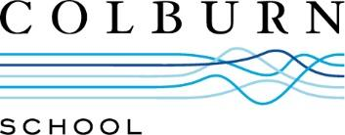 | Contact:  pr@colburnschool.edu

Community School of Performing Arts Overview
Founded in 1950 by the University of Southern California, the Community School of Performing Arts provides classes taught by highly-skilled instructors in instrumental and vocal music, drama, and early childhood arts education to students of all ages and skill levels. A member of the National Guild for Community Arts Education, the Community School is committed to ensuring community-wide access to quality arts instruction. Accredited by the National Association of Schools of Music (NASM), the Community School offers private lessons, group instruction, and ensemble experiences for instrumental and voice students. The Early Childhood curriculum is skill-based and is designed to explore music, theory, voice, movement, and drama.
Visit colburnschool.edu/cspa for more information about the Community School of Performing Arts, including its courses and faculty.
###

