Contact:
pr@colburnschool.edu

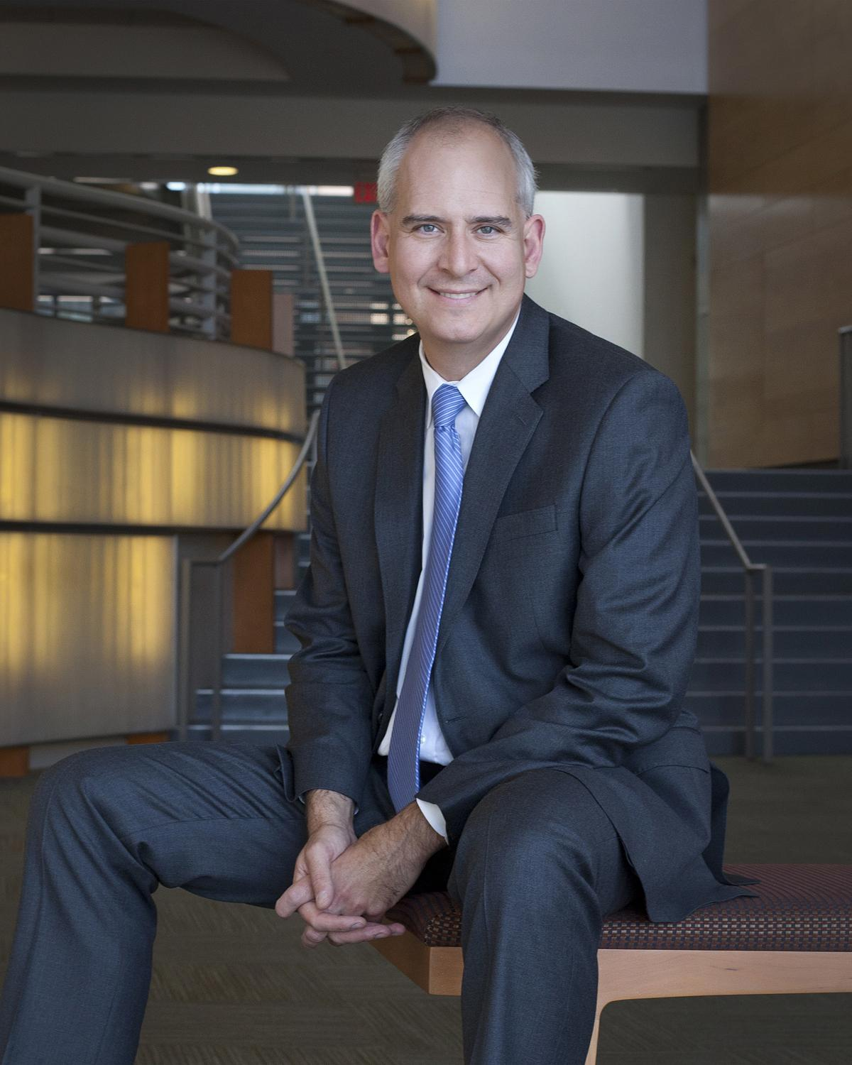
Sel Kardan, President and CEO
Sel Kardan joined the Colburn School as President and CEO in October, 2009, bringing years of experience as a performing arts executive, educator, and violist. In his role as President and CEO, Mr. Kardan shapes and leads the future path of Colburn, which serves more than 2,000 students from early childhood development to post graduate studies.
Mr. Kardan’s vision for the Colburn School is distinguished by his commitment to the school’s continuum of education, providing a place where students of all ages and skill levels can nurture their craft. In carrying out this institutional vision, Mr. Kardan has overseen the creation of two new academies: the Music Academy, a program for gifted young pre-college musicians, and the Dance Academy, a training program for exceptional pre-professional ballet dancers. Recognizing Colburn’s role as a cultural resource in the Los Angeles community, he has also worked to greatly expand community engagement initiatives and need based scholarship opportunities for Colburn students. Under Mr. Kardan’s administrative leadership, Colburn has enjoyed growth in enrollment, greater national visibility, increased philanthropic support, and stable financial health.
Prior to his arrival at Colburn in 2009, Mr. Kardan served as President and CEO of the Music Institute of Chicago, where he was the driving force behind the creation of the Academy, an elite pre-conservatory training center for young musicians. He was formerly Executive Director of the Shriver Hall Concert Series in Baltimore, a leading presenter of classical solo and chamber music, and Executive Director of the Heifetz International Music Institute, a summer training program and festival for gifted string players.
A native of Philadelphia, Mr. Kardan is a graduate of the Peabody Institute, and performed and taught at both the pre-college and collegiate level as a violist prior to beginning his administrative career.

Current as of June 19, 2017
###

